User’s Guide to the SIPFIS Website
Prescribed Fire and Air Quality Information for the South
What is SIPFIS?
SIPFIS is the acronym for Southern Integrated Prescribed Fire Information System. SIPFIS merges prescribed fire and air quality data into a common analysis framework. One of its objectives is to create a unified prescribed fire database for the southern U.S. providing multi-year data for fire occurrence and characteristics. Currently, this objective is fulfilled by combining data from prescribed burn permits and open burn authorizations issued by state agencies with satellite detections of fires in the region. The information available through SIPFIS includes air quality observations from routine monitoring networks and air quality, burn and burn impact predictions from Georgia Tech’s HiRes-2 forecasting system.
What information is available on SIPFIS Website?
We developed a web-based application to provide access to the data and facilitate visual analyses. The data can be accessed and analyzed interactively through user-friendly tools and online visualizations. The current focus of the website is the impacts of prescribed fire smoke on air quality. The impacts on human health will be focused next. At present, the following data are available on the SIPFIS Website.
Air Quality Observations: Ozone and PM_{2.5} observations from the national air quality monitoring network (https://www.airnow.gov); nationally, from January 1, 2015 to present; updated daily.
Air Quality Predictions: Ozone and PM2.5 predictions from the Georgia Tech’s HiRes-2 forecasting system (https://forecast.ce.gatech.edu); Contiguous U.S., from January 1, 2015 to present; updated daily.
HMS Detections: Locations of satellite fire detections from the Hazard Mapping System Fire and Smoke Product (http://www.ospo.noaa.gov/Products/land/hms.html); North America, from January 1, 2015 to present; updated daily.
Permits: Burn locations and areas from Florida’s open burn authorization records and Georgia’s burn permit records; Florida and Georgia, from January 1, 2015 to December 31, 2016; updated annually.
Burn, Air Quality (with burns) and Burn Impact Predictions: Prescribed burn activity, air quality with burns and burn impact from the Georgia Tech’s HiRes-2 forecasting system (https://forecast.ce.gatech.edu); Southeastern U.S., from January 1, 2015 to April 30, 2015; January 1, 2016 to April 30 2016; and January 1, 2017 to present; updated daily.

How to use SIPFIS Website?
We recommend using Microsoft Edge, Google Chrome, or Mozilla Firefox.
Current URL: https://sipc.ce.gatech.edu/SIPFIS/map/
The site opens with a display of yesterday’s PM_{2.5} observations in a region centered on Atlanta with Confederate Avenue as the selected site. The user can perform the following actions:
- Enter a different date or select a day from the calendar, starting from January 1, 2015,
- Select a different pollutant
- Zoom in or out on the map, or move to a different region,
- Select a different site on the map by clicking on the circular marker,
The pollutant choices are PM_{2.5} (default) and ozone. The names of the sites appear when hovering over their markers on the map, along with the most relevant value of the selected pollutant for that day (the daily average PM_{2.5}or the daily maximum 8-hour average ozone concentration). The circular marker is colored according to the color code for the air quality index displayed next to the pollutant name at the top of the map.
Click on “Ξ” above the instructions on the right hand side to open the time series pane. There are two time series: 1) daily and 2) hourly, both for a week-long period preceding the selected date. The observed and predicted pollutant concentrations are shown for comparison.
Since the predictions are drawn from the Georgia Tech’s HiRes-2 forecasting system, which produces a three-day forecast on a daily basis, there are three different sets of predictions:
- Latest is the forecast produced on the previous day,
- Earlier is the forecast produced two days before the selected date, and
- Earliest is the forecast produced three days before the selected date.
By displaying all three one can get an idea about the temporal variability of the predictions.
Clicking on the markers or lines in the legend makes those observations (dots) or predictions (lines) appear or disappear. Hovering over the time series plots displays the concentration values for a particular day.
To zoom-in a particular section of the graph, left-click and drag the mouse over that section; double click on the graph to zoom-out. To close the time series pane and go back to the instructions click on the “X”
The exercises on the following pages both explain how to use various functions of the SIPFIS website and illustrate how to conduct a preliminary smoke impact analysis.

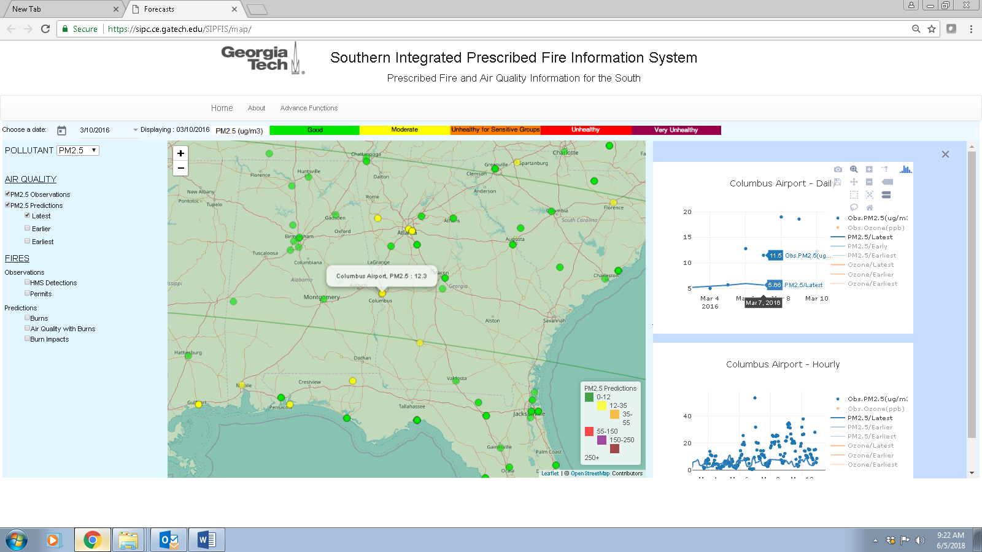
Try to recreate this figure as follows: 1) Choose March 10, 2016, 2) Check the box for “PM_{2.5} Observations” on the left side menu, 3) Center the map on Columbus, 4) Click on “Ξ” to open the time series pane, 5) Click on the circular marker for Columbus to display the time series for Columbus, 6) Deactivate ozone observations and ozone predictions on the time series by clicking on the orange markers and lines in the legends, 7) Hover on the daily time series plot to display the values on March 7, 2016, and 8) Check the box for “PM_{2.5} Predictions” on the left side menu to overlay the latest PM_{2.5} prediction field on the map.
Note that there are three different predictions: 1) Latest, 2) Earlier, and 3) Earliest. We forecast air quality every day for the next three days. The latest prediction is the forecast from the previous day’s cycle (tomorrow in the forecast issued on March 9). The earlier prediction is from the forecast issued two days before (the day after tomorrow in the forecast issued on March 8) and the earliest three days before (two days after tomorrow in the forecast issued on March 7). The latest and earlier PM_{2.5} prediction fields are green indicating “good” air quality (PM_{2.5} ˂ 12 μg/m³) everywhere in the region. There is no earliest prediction field indicating that no forecast was issued on March 7, probably due to technical difficulties.
The color comparison of the (latest) prediction with observations shows that PM_{2.5} was underestimated in the southeastern U.S. on March 10, 2016. While there are several observations above 12 μg/m³ (at sites with yellow markers) the prediction is below 12 μg/m³ everywhere. The comparison of the PM_{2.5} prediction to the PM_{2.5} observation on the daily time series shows an underestimation of 6.2 μg/m³ (hover over March 10; the observation is 12.3 μg/m³while the prediction is 6.1 μg/m³). This prediction does not include the potential contribution of prescribed burns.
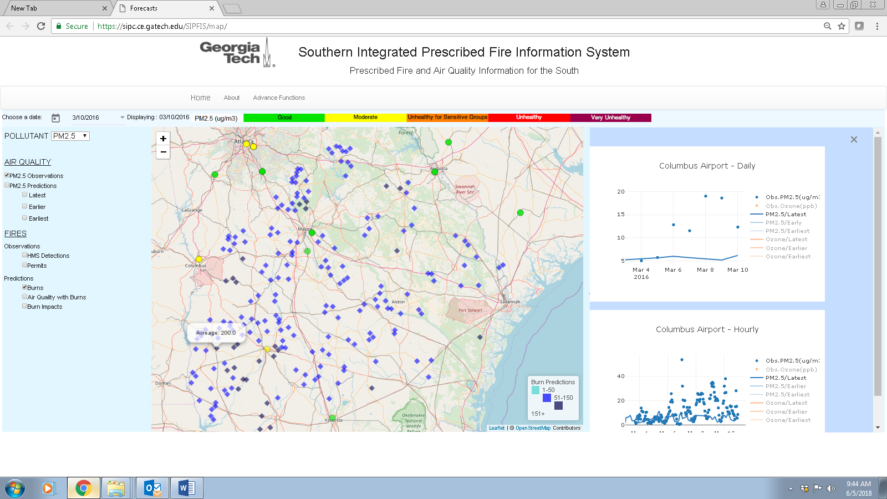
Try to recreate this figure by zooming in and moving the map. Then check the box for “Burns” (under “Predictions” on the left side menu. The blue diamonds mark the locations of predicted burns and their color tone indicate the acreage, lighter for smaller burns and darker for larger burns. Hovering over the diamonds displays the acreage. For example, there is a 200 acre burn to the south of Columbus.

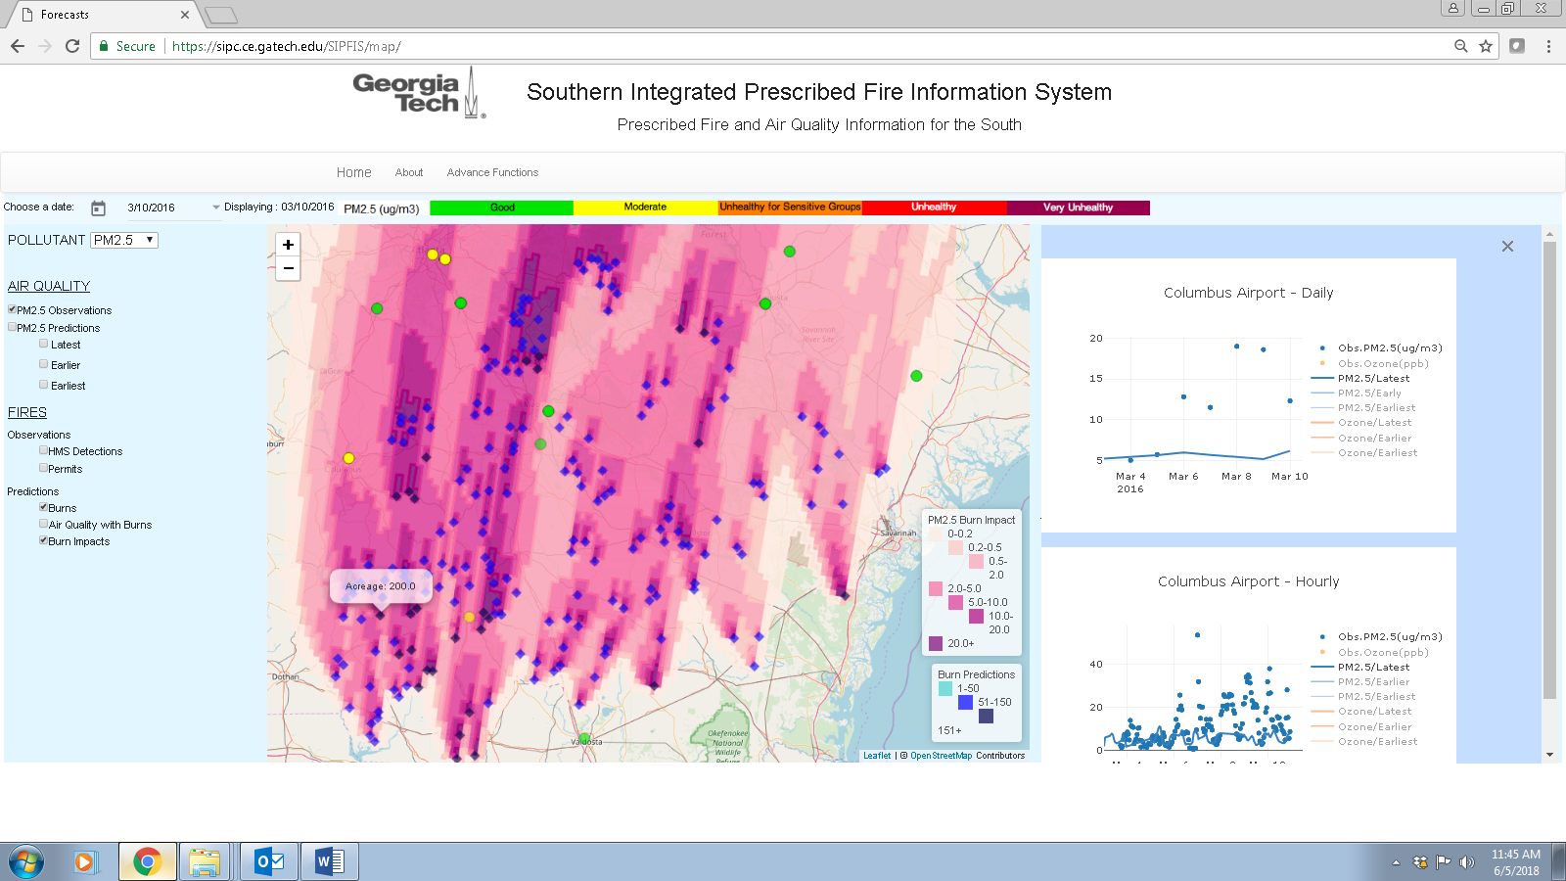
Now check the “Burn Impacts” box to see the predicted impacts of predicted burns on PM_{2.5} levels. Note the scale for burn impacts is smaller than what was used for PM_{2.5} air quality. This is so to better quantify the impacts. The shade of pink suggests that the impact of the burns on PM_{2.5} levels at Columbus is 2 to 5 μg/m³. Since the burn impact is not a directly measured quantity, its evaluation is difficult. In this case, the presence of burns upwind from Columbus and the magnitude of the underestimation in PM_{2.5} without the burns suggest that the predicted impacts may be in the right range.
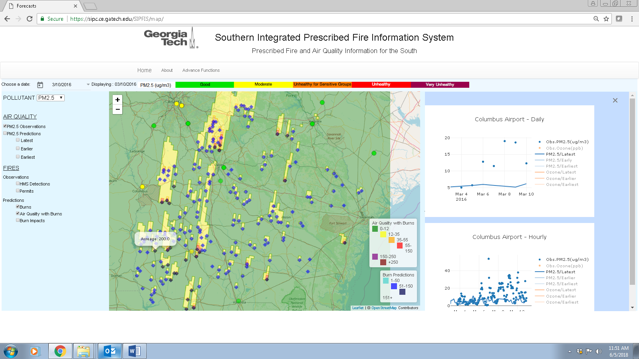
Now, uncheck the box for “Burn Impacts” and check the box for “Air Quality with Burns” instead. Clearly, the impact of burns is not sufficient to make up for the deficit in predicted PM_{2.5}.at Columbus, or any other site in the region.

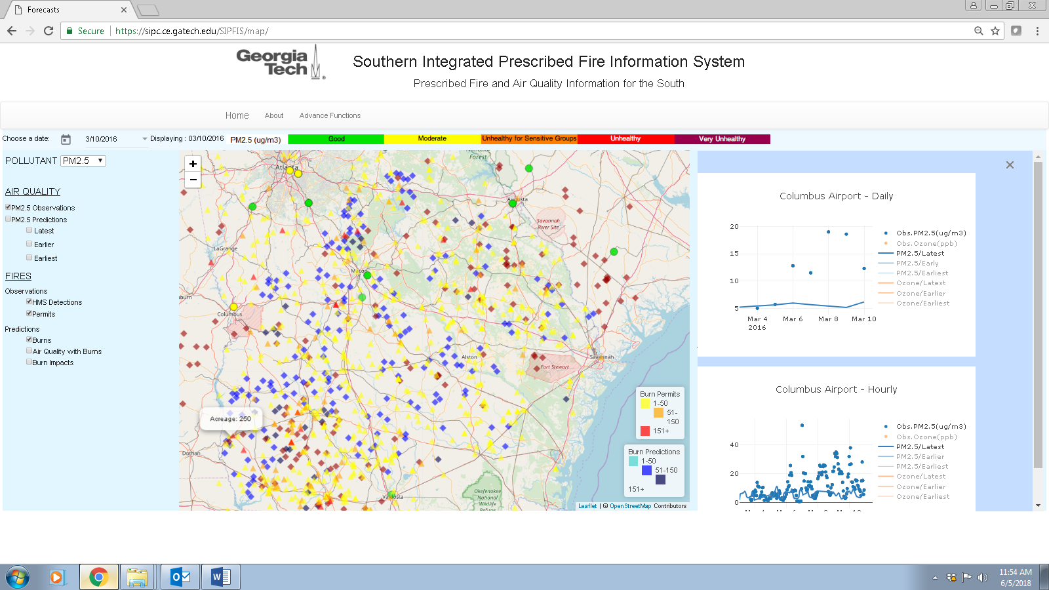
To investigate whether there were actual burns in the area, first uncheck the “Burn Impacts” box, then check the “HMS Detections” and “Permits” boxes. HMS data on the website consists of satellite-detected fire locations only (burgundy diamonds); there is no other information associated with these fires. The permits, represented by yellow, orange, or red triangles according to size of burn, provide acreage information in addition to location. For example, hovering over the permitted burn locations, one can see that there is a 250 acre burn not too far from where a 200 acre burn was predicted. This provides additional evidence for the accuracy of the burn and burn impact predictions.

